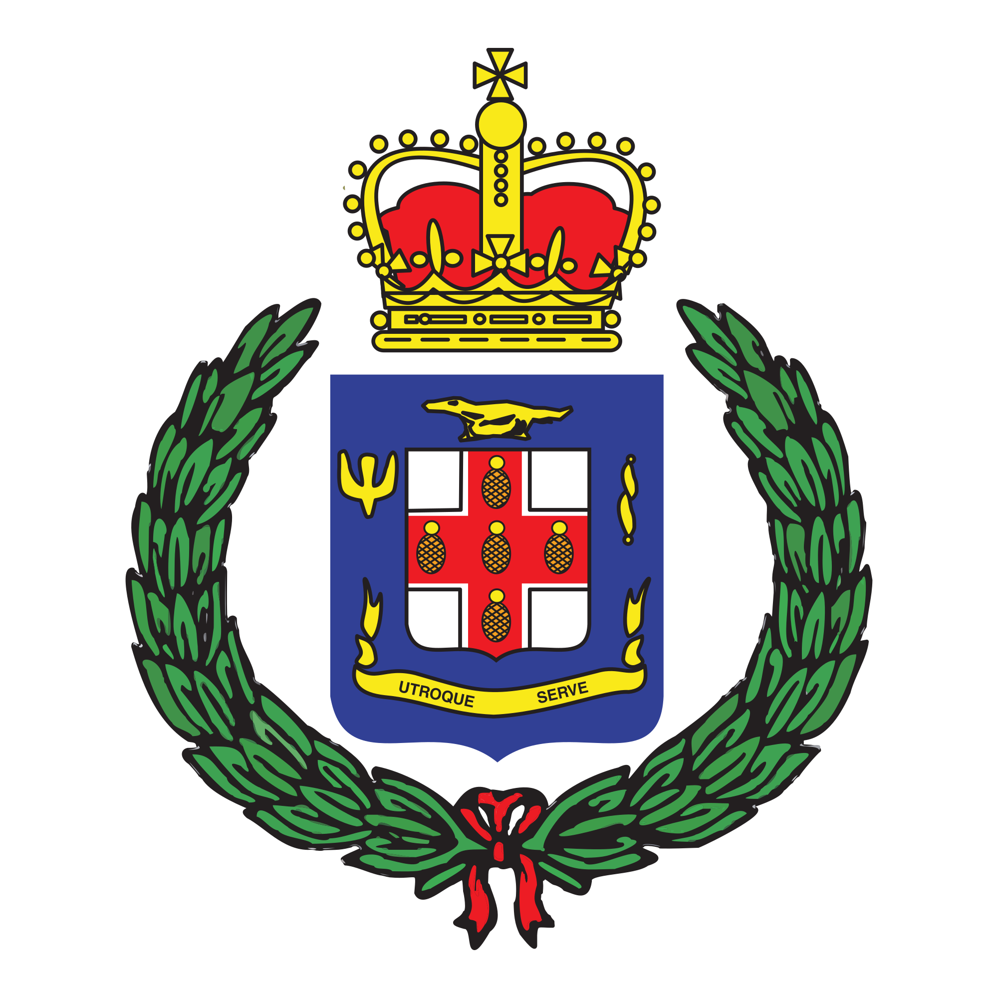
Corporate Communications Unit
101-105 Old Hope Road
Kingston 6
St. Andrew
Tel: (876) 978-2214
(876) 927-4427
Email: ccnops@jcf.gov.jm

Jamaica Constabulary Force
We Serve, Protect and Reassure

PRESS RELEASE

For immediate release

MAN TO FACE THE COURT FOR PORTMORE MURDER
December 24, 2019 – Thirty-year-old Tremaine Melford, otherwise called ‘Zico’, meter technician of 4 West, Greater Portmore in St. Catherine is scheduled to face the court to answer to the charge of Murder committed in the parish on Friday, December 06.

Dead is 76-year-old Alphanso Bailey of the above mentioned address.

Reports from the Portmore Police are that about 4:20 p.m., Bailey and Melford had a dispute when a knife was used to stab Bailey. On arrival of the Police, Bailey was assisted to hospital where he died while undergoing treatment.

Melford was subsequently charged however his court date will be announced at a later date.

-30-

