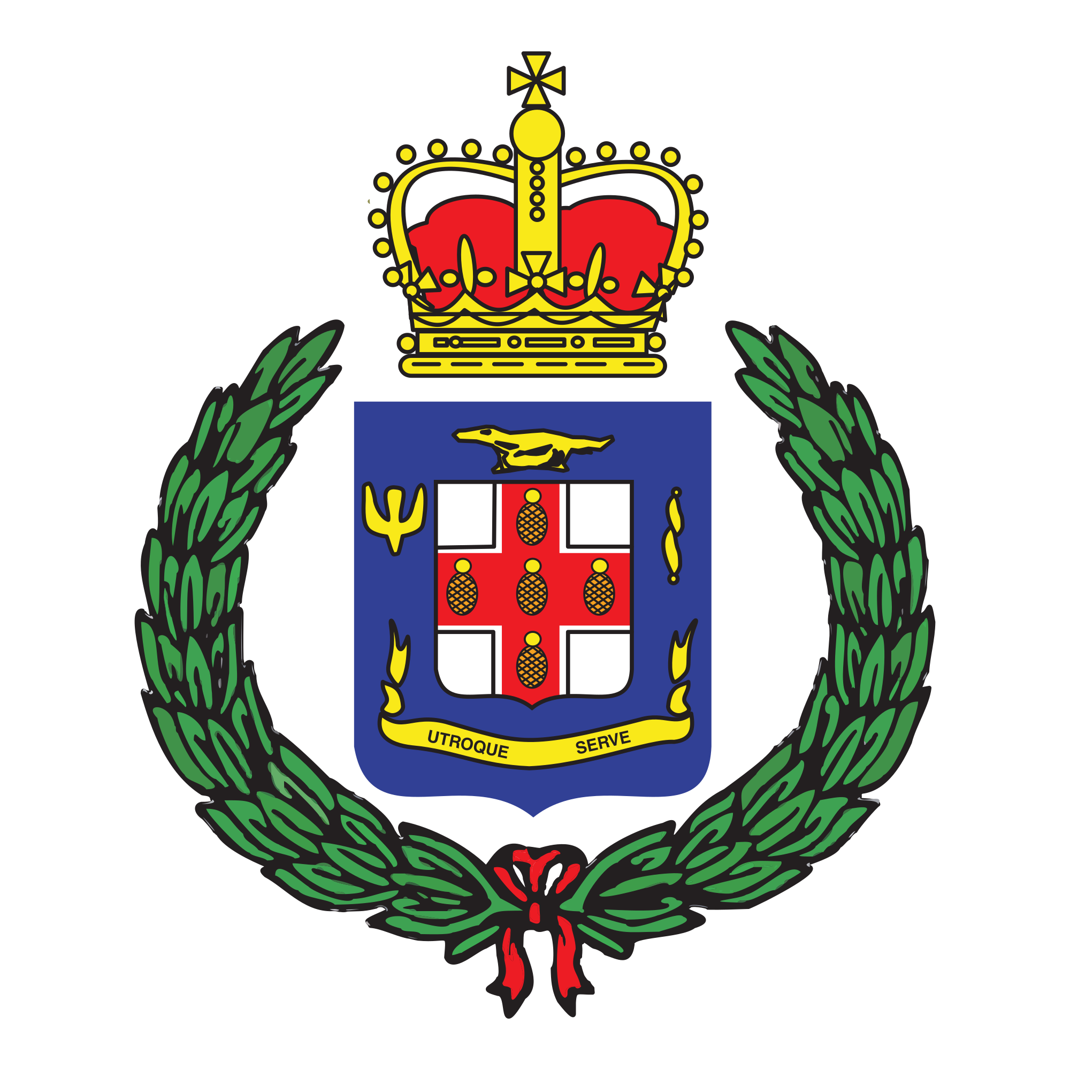
Corporate Communications Unit
101-105 Old Hope Road
Kingston 6
St. Andrew
Tel: (876) 978-2214
(876) 927-4427
Email: ccnops@jcf.gov.jm

Jamaica Constabulary Force
We Serve, Protect and Reassure

PRESS RELEASE

For immediate release

POLICE SEEK PUBLIC’S ASSISTANCE

December 24, 2019 – The Narcotics Police are seeking the public’s assistance in locating a Person of Interest in relation to an active investigation.

He is Jerome Jackson of a St. Mary address.

Jackson is being asked to report to the Area 2 Narcotics Police by 12:00 p.m., on Wednesday, December 26 as the detectives are of the view that he can assist in the investigations.
Meanwhile, anyone knowing the whereabouts of Jerome Jackson is being asked to contact the Area 2 Narcotics at 876-975-4779, Crime Stop at 311, the Police 119 emergency number or the nearest Police Station.
-30-

